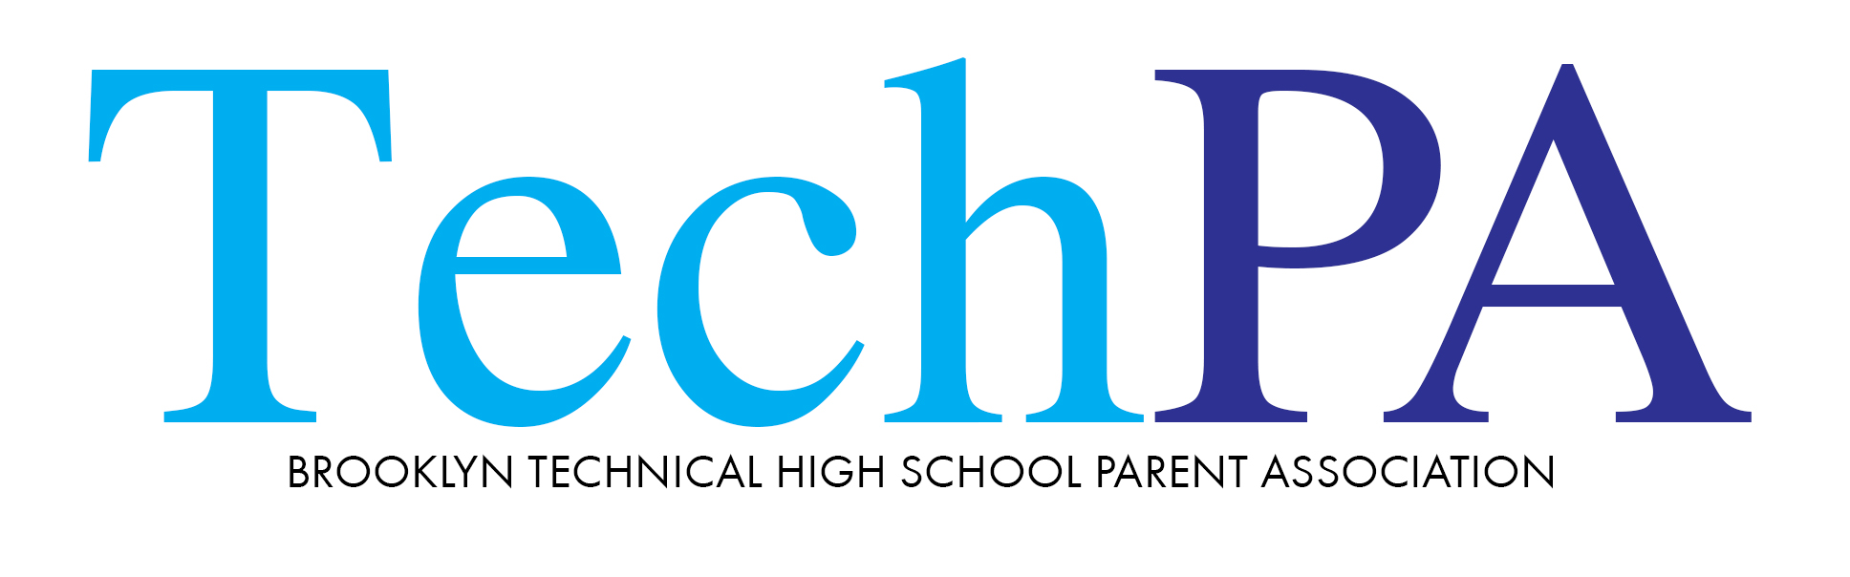

Brooklyn Tech PA Virtual Meeting Minutes via Zoom on 11/22/2021 @6:30 p.m.
PA Co- Recording Secretaries: Vito LaBella and Chris Zhang
- PA president Lincoln Favours called to order meeting, welcomed all participants, and introduced PA executive board members, including newly elected.
- Lincoln Favours stated SAT Prep class with Kaplan shall start in January 2022. Classes will occur in weekends. Lincoln is negotiating with Kaplan to remove cost of prep books. Prep class sign up link is www.instagramcom/bths_sat_prepclub.
- Planners arrived, shall be distributed soon.
- Treasurer Michelle Cheung shared October treasury report, thanks to all donors.
- Kim Jalet of Diversity committee presented the book, “We Are Not Like Them” by Christine Pride & Jo Piazza for book club. The next meeting to discuss the book will be on Monday, 12/6. She encouraged parents to join the fun event. She also spoke the next major on-line event of Lunar New Year Celebration will be held on 1/28/2022, and encouraged parents & children to help and participate. Students who participate in selected submissions will get 2 club credits. Jennifer Lu spoke of the event in Chinese. Online link to submit performances for this event is bthsdiversitycommittee@bths.edu.
- Susan Small of fundraising committee spoke importance of fundraising to help our children, and different way to donate to PA, check or on-line. Mia Lu covered it in Chinese. They both thanked all generous donors.
- Parent Coordinator – Mary Huhn talked the past parent teacher conference. The progress on updating parents’ email list continues.
- Lincoln Favours introduced Lia Aran, a former BTHS parent, founder of LUC. She showed LUC can help current HS students on college application. Enrolled college students would share past experience on applying for colleges, and many more benefits. The website is www.luklabs.com.
- Lincoln Favours introduced Johnny Ventura who updated information on special education program at BTHS, explained how IEP (individualized Education Plan) works.
- Q & A session with our Principal, Mr. David Newman, covered a long list of questions & concerns from parents, such as Covid-19 related, advisory program, SAT, lockers.

Please follow BTHS PA website https://www.brooklyntechpa.org/ for updates.
For anyone who is interested watching this recorded meeting, please log on YouTube https://www.youtube.com and search for “Brooklyn Tech PA general zoom meeting.

Prepared by Chris Zhang
Approved by Lincoln Favours

